Module 3

Technology inzetten voor het automatisch rijden

Naam: Bram van Gils PCN: 401949

Contents

Module 2.1 2

Code 2

Module 2.2 – 2.5 3

Flow-Chart 3

Code: 4

Variabelen en CheckPaused Method 4

CalibrateValues Method 4

PowerMotors + StopMotors Method 4

Evade Method 5

Main Method 5

Bronnen 6

# Module 2.1

## Code

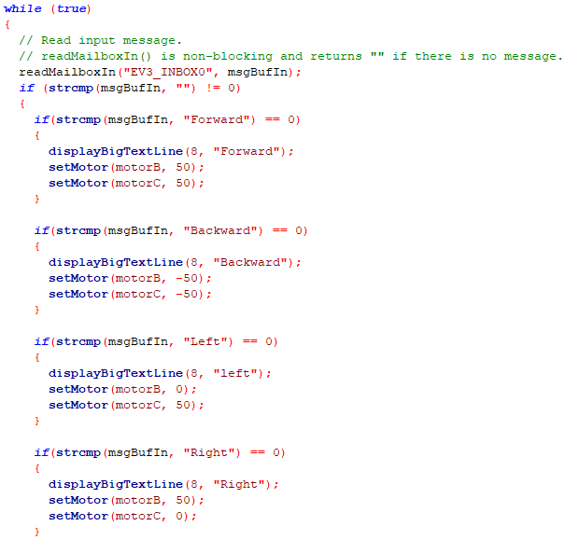

# Module 2.2 – 2.5

## Flow-Chart

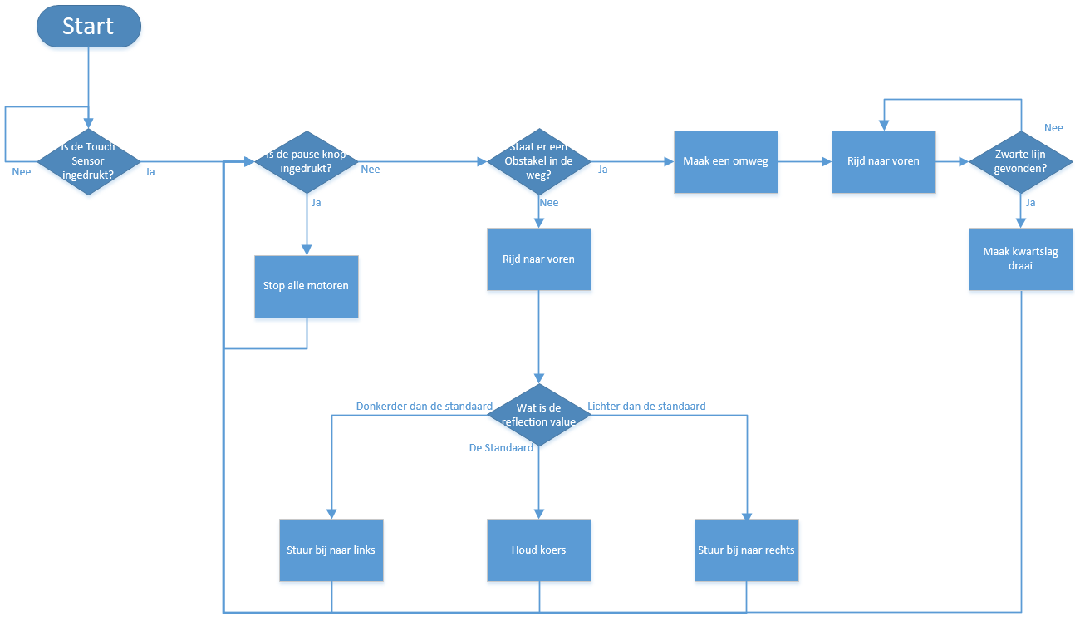

Link voor betere Weergave: <https://drive.google.com/open?id=1mMaBmnQnCb5VIEaaypnY8kOFj9mnrW-c>

## Code:

### Variabelen en CheckPaused Method

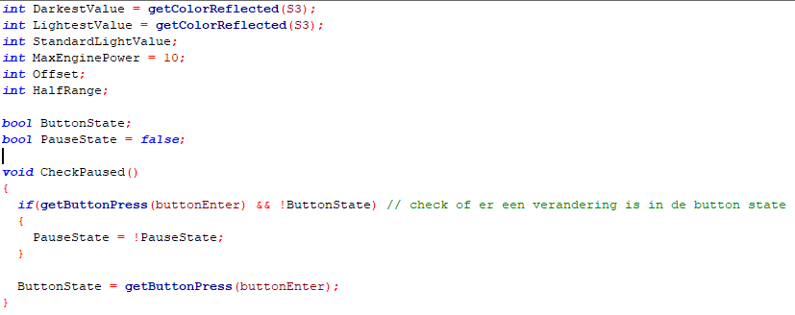

### CalibrateValues Method

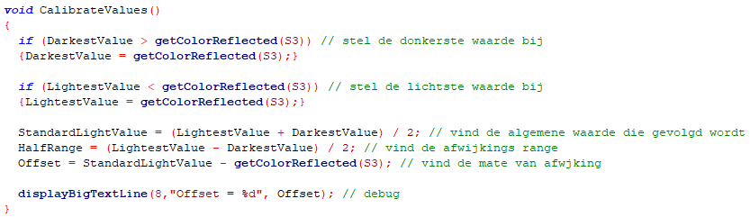

### PowerMotors + StopMotors Method

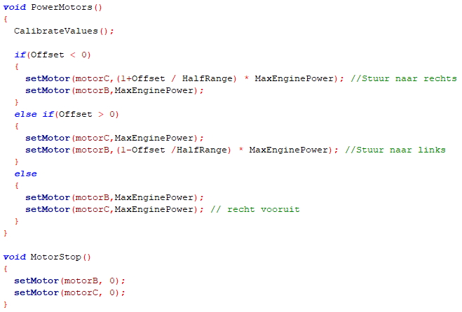

### Evade Method

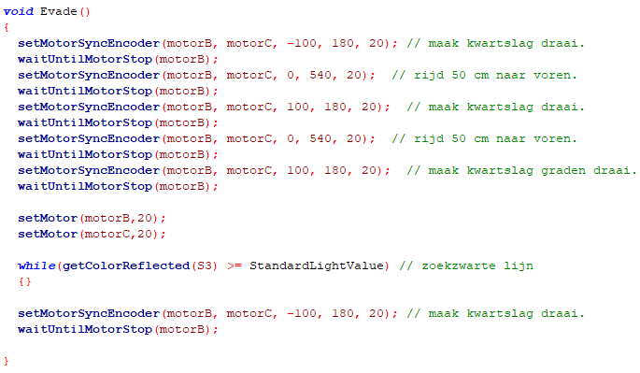

### Main Method

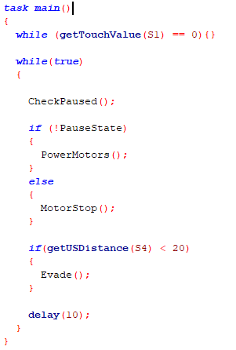

# Bronnen

<https://www.youtube.com/watch?v=BjVeWRNiddE>

<https://stackoverflow.com/questions/16627588/what-is-the-correct-string-terminator-in-c>

<https://www.tutorialspoint.com/cprogramming/c_arrays.htm>

<https://www.le.ac.uk/users/rjm1/cotter/page_22.htm>

<https://www.tutorialspoint.com/cprogramming/c_variables.htm>

<https://www.geeksforgeeks.org/understanding-extern-keyword-in-c/>

<https://stackoverflow.com/questions/15707732/what-does-array-means>